Data Analysis Mini-Report for ECCRAS Project Endline Evaluation

Phase 1: Data Preparation & Cleaning – ECCRAS Project
QUESTIONS: All Questions
Objective: Ensure the survey dataset is accurate, complete, and structured for robust analysis.

1. Data Entry & Validation
- Survey responses were transferred into a clean, structured dataset (DESECE_ECCRAS_Cleaned_Data.csv) with 195 respondents and 180 variables.
- The final sampled data is displayed on the table below:
- Data validation rules were applied to detect inconsistencies, out-of-range values, and missing responses.

2. Data Cleaning
- Missing Data:
  - Certain columns (e.g., intercropping_acres, trees_planted_number, vegetation_strip_meters etc) had missing values, which were identified and flagged.
  - Strategies were applied to handle missing data, including retaining key responses and preparing for imputation or exclusion in analysis.
- Variable Recoding:
  - New variables were created for analysis:
    - age derived from Age
    - location_name derived from Name of the Location
    - respondent_name derived from Name of the Respondent
    - primary_livelihood derived from Primary livelihood activity
    - County_name derived from Name of the County
    - agroforestry_heard derived from Agroforestry (trees on farm) Heard About
    - drought_varieties_adopted derived from Adopted/Used
    - crop_rotation_adopted derived from Crop rotation/intercropping(Adopted/Used)
    - Adoption_Score as a composite measure of adopted practices
-This variables derivation is done for all the 180 variable sof the dataset and the cleaned file is provided as reference.

3. Dataset Overview
- Respondent Demographics:
Category | Sub-Category | Count | Percentage (%)
Gender
 | Female | 143 | 73.3
 | Male | 52 | 26.7
Age Group
 | 18–25 | 1 | 0.5
 | 26–35 | 18 | 9.2
 | 36–45 | 29 | 14.9
 | 46–55 | 62 | 31.8
 | 56+ | 85 | 43.6
County
 | Bungoma County | 130 | 66.7
 | Trans Nzoia County | 65 | 33.3
Primary Livelihood
 | Crop Farming | 104 | 53.3
 | Crop & Livestock | 89 | 45.6
 | Livestock Rearing | 1 | 0.5
 | Other (Specify) | 1 | 0.5
Sub-location
 | Mt Elgon | 65 | 33.3
 | Bumula | 65 | 33.3
 | Trans-Nzoia West | 65 | 33.3

4. Key Observations
- The dataset is structured, clean, and ready for descriptive and inferential analysis.
- Minimal missing data in critical variables ensures confidence in adoption rate calculations.
- Sub-location, county, age, and gender distributions provide a foundation for disaggregated analysis in subsequent phases.

PHASE 2: Summary of Descriptive Analysis (For All Sections)
All Sections-Categorical and Numerical sections
This phase provides an overview of the dataset through descriptive statistics, including frequencies, percentages, means, and medians for key variables across demographics, categorical, and numeric sections. The sample consists of 195 respondents (143 females, 52 males), primarily from Bungoma County (130) and Trans Nzoia County (65). Age distribution skews older, with 56+ being the largest group (85 respondents). Primary livelihoods are dominated by crop farming (104) and mixed crop-livestock (89). Disaggregations reveal trends in adoption rates, knowledge sources, and practices, with high overall adoption of agroecological methods (e.g., 97%+ for composting and water harvesting).

Sample Characteristics (Overall Demographics)
- Gender Breakdown - Females represent 73.3% (143), males 26.7% (52).
- Age Groups: 56+ (43.6%, 85); 46-55 (31.8%, 62); 36-45 (14.9%, 29); 26-35 (9.2%, 18); 18-25 (0.5%, 1).
Age Group | Count | Percentage
18-25 | 1 | 0.51%
26-35 | 18 | 9.23%
36-45 | 29 | 14.87%
46-55 | 62 | 31.79%
56+ | 85 | 43.59%
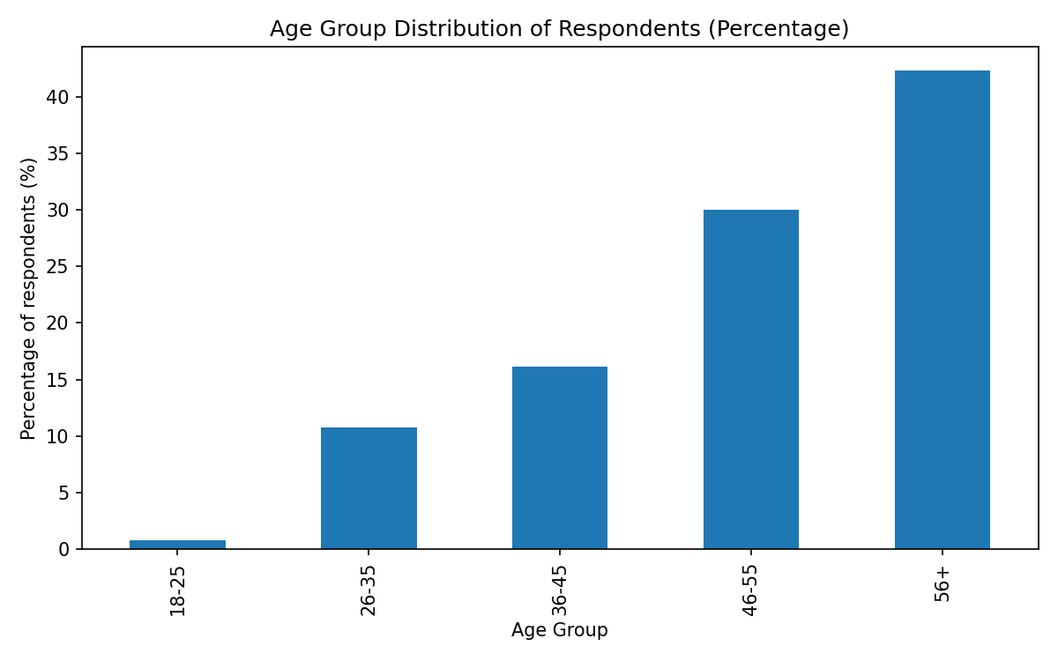
- County Distribution: Bungoma (66.7%, 130); Trans Nzoia (33.3%, 65).
- Primary Livelihood: Crop farming (53.3%, 104); Crop & Livestock (45.6%, 89); Livestock rearing/Other (0.5% each, 1).
- Sublocations: Even split across Bumula, Mt Elgon (33.3% each, 65), and Trans-Nzoia West (33.3%, 65).
- Top locations: Sikhendu (11.8%, 23); Chemses (5.6%, 11); Kibuke (5.1%, 10).

Table: Demographic Profile of Respondents
Demographic Variable | Category | Count | Percentage
Gender | Female | 143 | 73.30%
 | Male | 52 | 26.70%
Age Group | 56+ years | 85 | 43.60%
 | 46-55 years | 62 | 31.80%
 | 36-45 years | 29 | 14.90%
 | 26-35 years | 18 | 9.20%
 | 18-25 years | 1 | 0.50%
County | Bungoma County | 130 | 66.70%
 | Trans Nzoia County | 65 | 33.30%
Primary Livelihood | Crop Farming | 104 | 53.30%
 | Crop & Livestock | 89 | 45.60%
 | Livestock Rearing | 1 | 0.50%
 | Other | 1 | 0.50%
Insights
- The data reflects a sample of primarily middle-aged and older smallholder farmers, with a significant gender disparity towards women.
- The distribution between the two counties and farming systems provides a good basis for comparative analysis.

Key Categorical Variables (Frequencies and Percentages)
Common themes include high awareness and adoption of practices like composting (99% heard, 98% adopted overall). Knowledge sources are predominantly from project training (e.g., DESECE, 86%). Most important practices: Compost use (41.5%). Climate worries: Prolonged drought (29.2%). Challenges: High input costs (13.8%).
- Top 5 Categorical Variables (Overall)
Variable | Top Response | Count | Percentage
Location name | Sikhendu | 23 | 11.80%
Respondent name | Richard Wafula / Elizabeth Wafula | 2 each | 1.00%
age | 56+ | 85 | 43.60%
Primary livelihood(other) | Yes | 1 | 0.50%
agroforestry_heard |  | 192 | 98.50%

- Disaggregation by Age Group (Example: Briquette No Participation Reasons):
  - 18-25: 100% "Trained".
  - 26-35: 61.1% "Trained"; 5.6% each for "I attended", "I was sick".
  - 36-45: 65.5% "Trained"; 3.4% each for "Old age", "Attended the training".
  - 46-55: 75.8% "Trained"; 3.2% "Participated".
  - 56+: 78.8% "Trained"; 2.4% "Was trained".

- Disaggregation by County (Briquette No Participation Reasons)
Reason | Bungoma Count (%) | Trans Nzoia Count (%)
Trained | 2 (1.5%) | 2 (3.1%)
Was trained | 3 (2.3%) | 2 (3.1%)
I was sick | 2 (1.5%) | 0 (0%)
(Bungoma shows higher "Old age" at 0.8%; Trans Nzoia higher "I attended the training" at 1.5%.)

- Disaggregation by Primary Livelihood (Beneficiary Status, Example: Briquette Reasons)
Reason | Crop & Livestock (%) | Crop Farming (%)
Lack of raw materials | 16.90% | 1.00%
Time-consuming | 1.10% | 1.00%
Equipment | 2.20% | 1.00%
(Crop & Livestock beneficiaries report higher equipment issues.)

Key Numeric Variables (Means, Medians)
Numeric metrics show moderate input use (e.g., compost: mean 11.4 bags/season) and small-scale practices (e.g., cover crops: mean 0.63 acres). Family knowledge sources are low (mean 0.04).
- Overall Numeric Stats
Variable | Count | Mean | Median | Min | Max | Std
Compost bags/season | 192 | 11.4 | 7.5 | 0.2 | 100 | 13.8
Manure bags/season | 184 | 10.5 | 6 | 0 | 125 | 13.9
Acres under cover crops | 179 | 0.63 | 0.5 | 0.05 | 4 | 0.55

- Disaggregation by Gender
  - Compost: Females (mean 10.0, median 7.0); Males (mean 15.1, median 9.0) – males use more.
  - Manure: Similar means (~10.5), but females have higher std (15.4 vs. 9.3).
  - Source family: Females (mean 0.05); Males (mean 0.02).
- Disaggregation by Age Group
  - Compost: Increases with age; 18-25 (mean 8.0); 56+ (mean 11.8, median 6.0).
  - Acres cover crops: 56+ highest (mean 0.68); 26-35 lowest (mean 0.53).
  - Briquette reason time: Highest in 26-35 (mean 0.40).
- Disaggregation by County
  - Compost: Bungoma (mean 12.9, median 10.0); Trans Nzoia (mean 8.4, median 5.0).
  - Manure: Bungoma (mean 11.5); Trans Nzoia (mean 8.4) – Bungoma higher.
  - Source family: Bungoma (mean 0.05); Trans Nzoia (mean 0.03).
- Disaggregation by Primary Livelihood
  - Compost: Crop & Livestock (mean 14.9); Crop farming (mean 8.5).
  - Acres cover crops: Crop farming (mean 0.69); Crop & Livestock (mean 0.55).
  - Briquette reason equipment: Crop & Livestock (mean 0.24); Crop farming (mean 0.10).

Adoption Rates (Percentages)
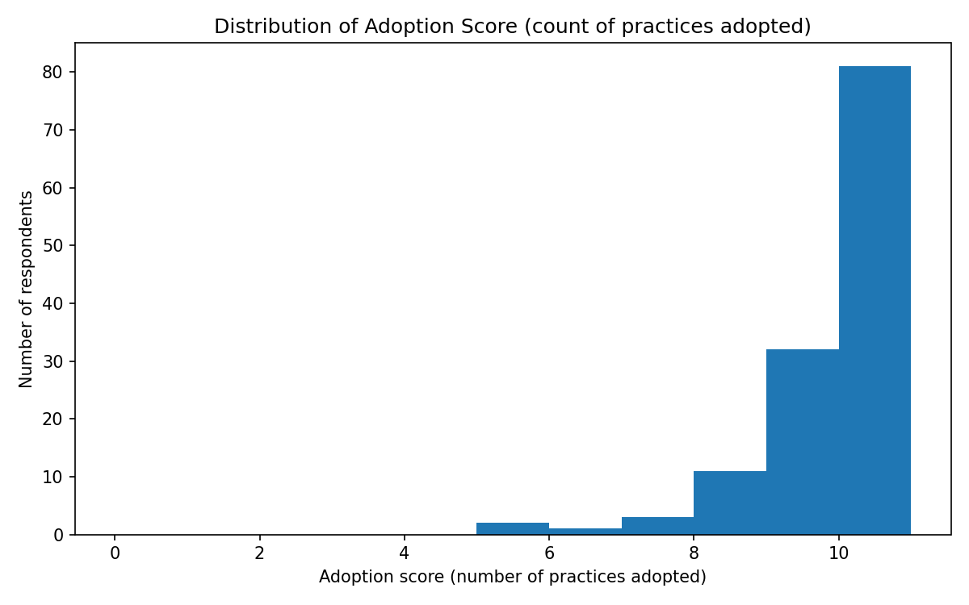
High adoption across practices, with slight variations:
- By Gender
Practice | Female (%) | Male (%)
Agroforestry | 97.2 | 98.1
Drought varieties | 88.8 | 88.5
Composting | 97.9 | 100
(Males slightly higher in mulching, soil conservation.)

- By County
Practice | Bungoma (%) | Trans Nzoia (%)
Agroforestry | 98.4 | 95.4
Water harvesting | 100 | 98.5
(Bungoma leads in most; Trans Nzoia in drip irrigation.)

Table: Top Adopted Practices and Perceived Impact
Practice | Heard of Practice | Adopted Practice | Most Common Perceived Effect
Agroforestry | 98.50% | 96.90% | Very Positive
Drought-Tolerant Varieties | 95.40% | 88.70% | Very Positive
Crop Rotation | 99.50% | 99.00% | Very Positive
Mulching | 95.40% | 88.70% | Very Positive
Composting | 99.50% | 98.50% | Very Positive
Water Harvesting | 99.00% | 99.00% | Very Positive
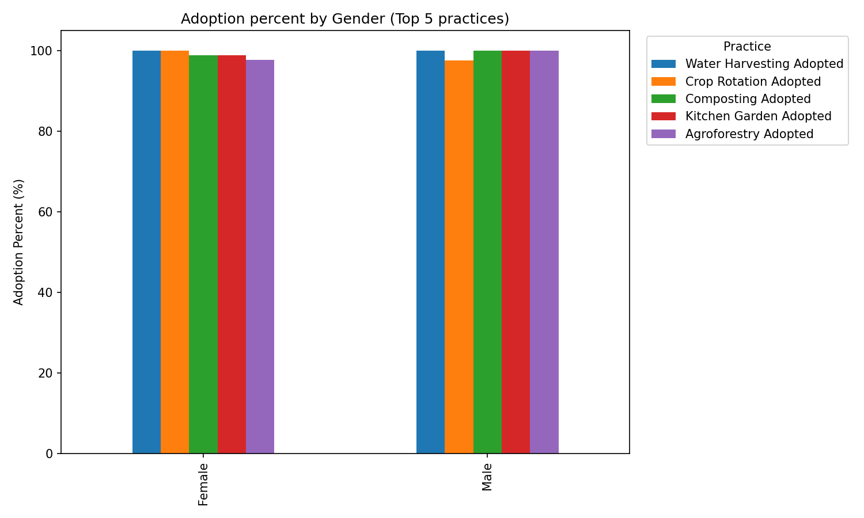
In sum, the data highlights gender and county disparities (e.g., females in Bungoma dominate adoption but use fewer inputs), with older groups showing higher means in land-based practices. Trends suggest project training drives positive effects, though challenges like costs persist.
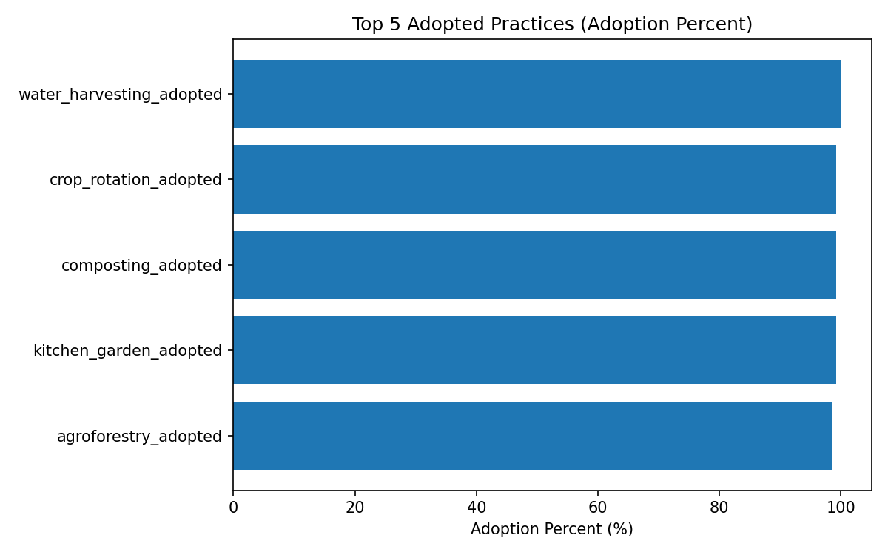

Awareness of Practices

Agroforestry
- Heard about: 98.5% of respondents have heard about agroforestry.
- Adopted: 96.9% have adopted it.
- By Gender & Age: Adoption is high across all groups; slightly lower among older respondents (56+).
- By County: Bungoma leads in both awareness (99.2%) and adoption (97.7%).

Table: Agroforestry Adoption by Gender
Gender | Yes (%) | No (%)
Female | 96.5 | 2.8
Male | 98.1 | 1.9

Drought-Resistant Varieties
- Heard about: 95.4% of respondents.
- Adopted: 88.7% of respondents.
- Observation: Adoption decreases slightly with increasing age (highest in 36-45 at 96.6%, lowest in 56+ at 84.7%).

Crop Rotation
- Heard about: 99.5%.
- Adopted: 99.0%, indicating widespread acceptance.
- By County & Livelihood: Nearly universal awareness and adoption across both Bungoma and Trans Nzoia counties.

Mulching
- Heard about: 95.4%.
- Adopted: 88.7%.
- Insight: Adoption is lower among older respondents and Trans Nzoia County (86.2%) compared to Bungoma (90%).

Composting
- Heard about: 99.5%.
- Observation: Awareness is very high across all demographics. Adoption data not fully presented but likely similar trends to other practices.

Livelihood Diversification
- Most respondents are engaged in Crop & Livestock (44.9%) or Crop farming (42.3%).
- Very few practice small business and crop farming (0.5%) or Livestock rearing alone.
Table : Primary Livelihood (Overall)
Livelihood | Count | Percentage
Crop & Livestock | 89 | 44.90%
Crop farming | 104 | 42.30%
Livestock rearing | 1 | 0.50%
Other (Small business) | 1 | 0.50%

Key Insights
- The survey sample is older-skewed, predominantly 46+ years.
- Awareness and adoption of sustainable agricultural practices (agroforestry, crop rotation, drought varieties, mulching, composting) are high, particularly in Bungoma County.
- Adoption slightly declines with age and varies by livelihood type and county.
- Crop & Livestock and Crop farming remain the dominant livelihood activities, emphasizing the relevance of targeted interventions in these areas.

1. Composting
Awareness (Heard of Composting):
- Overall, 100% of respondents in Bungoma and 98.5% in Trans Nzoia had heard of composting.
- Sublocations like Bumula and Mt Elgon reported 100% awareness.
- Across livelihoods, crop farming and crop & livestock farmers almost universally heard of composting.
Adoption (Practicing Composting):
- Overall adoption is very high: 98.5%.
- Slightly higher adoption among males (100%) compared to females (97.9%).
- Older farmers (56+) showed slightly lower adoption (97.6%) than younger age groups.
- Bungoma had slightly higher adoption (99.2%) than Trans Nzoia (96.9%).
- Sublocation-level adoption mirrors this trend: Trans-Nzoia West slightly lower (96.9%).
Key Insight: Composting is almost universally known and practiced, with minor gaps among older farmers, females, and some Trans Nzoia sublocations.

2. Water Harvesting
Awareness
- Nearly universal awareness (≈99% overall).
- Very minor missing data (1 respondent NaN).
- Awareness is consistent across gender, age, county, and livelihood.
Adoption
- Extremely high adoption: 99.5% overall.
- Females slightly less than males (99.3% vs 100%).
- Older respondents (56+) had slightly lower adoption (98.8%).
- Adoption gaps minimal across counties and sublocations.
Key Insight: Water harvesting is widely known and adopted across all demographics, indicating strong program penetration.

3. Drip Irrigation
Awareness
- Lower than composting and water harvesting: 82.6% overall.
- Slight gender gap: females (83.2%), males (80.8%).
- Age shows a declining awareness trend with older farmers: 56+ at 80%.
- Bungoma and Trans Nzoia awareness roughly similar (83.8% vs 80%).
- Crop & livestock farmers less aware (73%) compared to crop farmers (90%).
Adoption
- Overall adoption: 76.4%.
- Gender gap: females (77.6%), males (73.1%).
- Older farmers adopt less: 56+ adoption 71.8%.
- Sublocation variation: Mt Elgon lower adoption (70.8%) vs Bumula (80%) and Trans-Nzoia West (78.5%).
- Crop & livestock farmers lower adoption (62.9%) vs crop farmers (87.5%).
Key Insight - Drip irrigation shows the largest knowledge and adoption gaps, particularly among older farmers, women, and crop & livestock farmers. Targeted awareness campaigns could improve uptake.

4. Kitchen Gardens
Awareness (Heard of)
Category | Count_No | Count_Yes | % No | % Yes
Overall | 1 | 194 | 0.51 | 99.49
Gender: Female | 1 | 142 | 0.7 | 99.3
Gender: Male | 0 | 52 | 0 | 100
Age 18-25 | 0 | 1 | 0 | 100
Age 26-35 | 0 | 18 | 0 | 100
Age 36-45 | 0 | 29 | 0 | 100
Age 46-55 | 0 | 62 | 0 | 100
Age 56+ | 1 | 84 | 1.18 | 98.82
County: Bungoma | 0 | 130 | 0 | 100
County: Trans Nzoia | 1 | 64 | 1.54 | 98.46
Sublocation: Bumula | 0 | 65 | 0 | 100
Sublocation: Mt Elgon | 0 | 65 | 0 | 100
Sublocation: Trans-Nzoia West | 1 | 64 | 1.54 | 98.46

- Almost universal awareness: 99–100% across most sublocations.
- Minor gap in Trans-Nzoia West (98.5%).

Adoption (Practicing)
Category | Count_No | Count_Yes | % No | % Yes
Overall | 2 | 193 | 1.03 | 98.97
Gender: Female | 2 | 141 | 1.4 | 98.6
Gender: Male | 0 | 52 | 0 | 100
Age 18-25 | 0 | 1 | 0 | 100
Age 26-35 | 0 | 18 | 0 | 100
Age 36-45 | 0 | 29 | 0 | 100
Age 46-55 | 1 | 61 | 1.61 | 98.39
Age 56+ | 1 | 84 | 1.18 | 98.82
County: Bungoma | 1 | 129 | 0.77 | 99.23
County: Trans Nzoia | 1 | 64 | 1.54 | 98.46
Sublocation: Bumula | 0 | 65 | 0 | 100
Sublocation: Mt Elgon | 1 | 64 | 1.54 | 98.46
Sublocation: Trans-Nzoia West | 1 | 64 | 1.54 | 98.46

- Very high: 98.97% overall.
- Females slightly lower adoption (98.6%) than males (100%).
- Older farmers (46–55, 56+) slightly lower adoption (~98–98.8%).
- Adoption is similar across counties and sublocations, with very minor gaps.
Insight: Kitchen gardens are widely known and adopted, with minimal demographic gaps.

5. Food Forests
Awareness
Category | Count_No | Count_Yes | % No | % Yes
Overall | 3 | 192 | 1.54 | 98.46
Gender: Female | 3 | 140 | 2.1 | 97.9
Gender: Male | 0 | 52 | 0 | 100
Age 18-25 | 0 | 1 | 0 | 100
Age 26-35 | 0 | 18 | 0 | 100
Age 36-45 | 0 | 29 | 0 | 100
Age 46-55 | 0 | 62 | 0 | 100
Age 56+ | 3 | 82 | 3.53 | 96.47
County: Bungoma | 0 | 130 | 0 | 100
County: Trans Nzoia | 3 | 62 | 4.62 | 95.38
Sublocation: Bumula | 0 | 65 | 0 | 100
Sublocation: Mt Elgon | 0 | 65 | 0 | 100
Sublocation: Trans-Nzoia West | 3 | 62 | 4.62 | 95.38

- High overall awareness: 98.5%.
- Lower among older farmers (56+ at 96.5%) and in Trans Nzoia County (95.4%).
- Slight gender gap: females 97.9%, males 100%.

Adoption
Category | Count_No | Count_Yes | % No | % Yes
Overall | 8 | 187 | 4.1 | 95.9
Gender: Female | 6 | 137 | 4.2 | 95.8
Gender: Male | 2 | 50 | 3.85 | 96.15
Age 18-25 | 0 | 1 | 0 | 100
Age 26-35 | 0 | 18 | 0 | 100
Age 36-45 | 1 | 28 | 3.45 | 96.55
Age 46-55 | 1 | 61 | 1.61 | 98.39
Age 56+ | 6 | 79 | 7.06 | 92.94
County: Bungoma | 5 | 125 | 3.85 | 96.15
County: Trans Nzoia | 3 | 62 | 4.62 | 95.38
Sublocation: Bumula | 1 | 64 | 1.54 | 98.46
Sublocation: Mt Elgon | 4 | 61 | 6.15 | 93.85
Sublocation: Trans-Nzoia West | 3 | 62 | 4.62 | 95.38

- Overall adoption: 95.9%.
- Slightly lower adoption in older farmers (56+ at 92.9%).
- Adoption by county: Bungoma 96.1%, Trans Nzoia 95.4%.
- Sublocation gaps: Mt Elgon slightly lower adoption (93.8%).
Insight: Food forests are well-known and adopted but show slightly larger gaps among older farmers and in some sublocations.

6. Soil Conservation
Awareness
Category | Count_No | Count_Yes | % No | % Yes
Overall | 12 | 183 | 6.15 | 93.85
Gender: Female | 10 | 133 | 6.99 | 93.01
Gender: Male | 2 | 50 | 3.85 | 96.15
Age 18-25 | 0 | 1 | 0 | 100
Age 26-35 | 1 | 17 | 5.56 | 94.44
Age 36-45 | 1 | 28 | 3.45 | 96.55
Age 46-55 | 1 | 61 | 1.61 | 98.39
Age 56+ | 9 | 76 | 10.59 | 89.41
County: Bungoma | 7 | 123 | 5.38 | 94.62
County: Trans Nzoia | 5 | 60 | 7.69 | 92.31
Sublocation: Bumula | 2 | 63 | 3.08 | 96.92
Sublocation: Mt Elgon | 5 | 60 | 7.69 | 92.31
Sublocation: Trans-Nzoia West | 5 | 60 | 7.69 | 92.31

- Slightly lower than other practices: 93.8% overall.
- Gender gap: females 93%, males 96.1%.
- Age-related gaps: older farmers (56+) at 89.4%.
- County differences: Bungoma 94.6%, Trans Nzoia 92.3%.
- Sublocations like Mt Elgon and Trans-Nzoia West slightly lower awareness (~92.3%).

Adoption
Category | Count_No | Count_Yes | % No | % Yes
Overall | 15 | 180 | 7.69 | 92.31
Gender: Female | 12 | 131 | 8.39 | 91.61
Gender: Male | 3 | 49 | 5.77 | 94.23
Age 18-25 | 0 | 1 | 0 | 100
Age 26-35 | 1 | 17 | 5.56 | 94.44
Age 36-45 | 1 | 28 | 3.45 | 96.55
Age 46-55 | 1 | 61 | 1.61 | 98.39
Age 56+ | 12 | 73 | 14.12 | 85.88
County: Bungoma | 9 | 121 | 6.92 | 93.08
County: Trans Nzoia | 6 | 59 | 9.23 | 90.77
Sublocation: Bumula | 3 | 62 | 4.62 | 95.38
Sublocation: Mt Elgon | 6 | 59 | 9.23 | 90.77
Sublocation: Trans-Nzoia West | 6 | 59 | 9.23 | 90.77

- Overall adoption: 92.3%.
- Females 91.6%, males 94.2%.
- Older farmers (56+) adoption is lowest at 85.9%.
- County differences: Bungoma 93.1%, Trans Nzoia 90.8%.
- Sublocation adoption: Mt Elgon & Trans-Nzoia West lowest (~90.8–90.8%).
Insight- Soil conservation shows the largest knowledge and adoption gaps, especially among older farmers, females, and certain sublocations. This indicates a need for targeted awareness and training interventions.

6. Knowledge Sources
Knowledge Source | Count | %
Project training – DESECE | 167 | 85.64
Demonstration farm / field day – Other NGO | 4 | 2.05
Project training – DESECE Radio/TV | 3 | 1.54
Project training – DESECE Neighbour / friend | 3 | 1.54
Radio/TV Project training – DESECE | 3 | 1.54
Neighbour / friend Project training – DESECE | 2 | 1.03
Project training – DESECE Government agricultural officer | 2 | 1.03
Project training – DESECE Neighbour/friend Family member | 2 | 1.03
Neighbour or friend | 1 | 0.51
Project training – DESECE Radio/TV Family member | 1 | 0.51
Project training – DESECE Government officer + Radio/TV + Neighbour + Family | 1 | 0.51
Family member Project training – DESECE | 1 | 0.51
Radio/TV Project training – DESECE Neighbour / Family member | 1 | 0.51
Other combinations (multiple sources) | 1 | 0.51

- Project training – DESECE is the dominant source (85.6%).
- Other sources are minor: radio/TV, neighbors/friends, government agricultural officers, family members (<2% each).
- This highlights the importance of project-led trainings in promoting sustainable agricultural practices.
- Minor overlapping sources suggest farmers often receive information from multiple channels.

1) Knowledge Sources by Gender
Gender | Demonstration Farm/Field Day | Project Training (DESECE) | Family Member | Neighbour/Friend | Radio/TV | Govt. Agric Officer | Total Yes
Female | 3 | 123 | 1 | 1 | 2 | 1 | 1
Male | 1 | 44 | 0 | 0 | 1 | 1 | 1

2) Knowledge Sources by Age Group
Age Group | Demonstration Farm/Field Day | Project Training (DESECE) | Family Member | Neighbour/Friend | Radio/TV | Govt. Agric Officer | Total Yes
18–25 | 0 | 1 | 0 | 0 | 0 | 0 | 0
26–35 | 0 | 17 | 0 | 0 | 0 | 0 | 1
36–45 | 1 | 25 | 1 | 0 | 0 | 0 | 0
46–55 | 2 | 52 | 0 | 1 | 1 | 1 | 0
56+ | 1 | 72 | 0 | 1 | 1 | 0 | 0

3) Knowledge Sources by County
County | Demonstration Farm/Field Day | Project Training (DESECE) |  | Family Member | Neighbour/Friend | Radio/TV | Govt. Agric Officer | Total Yes
Bungoma County | 4 | 109 |  | 1 | 1 | 1 | 1 | 0
Trans Nzoia County | 0 | 58 |  | 0 | 1 | 1 | 0 | 1

4) Knowledge Sources by Primary Livelihood
Primary Livelihood | Demonstration Farm/Field Day | Project Training (DESECE) | Family Member | Neighbour/Friend | Radio/TV | Govt. Agric Officer | Total Yes
Crop & Livestock | 2 | 77 | 1 | 2 | 0 | 1 | 0
Crop Farming | 2 | 88 | 1 | 1 | 2 | 1 | 1
Livestock Only | 0 | 1 | 0 | 0 | 0 | 0 | 0
Other | 0 | 1 | 0 | 0 | 0 | 0 | 0

General Trends in Knowledge, Adoption, and Perceptions

Overall Patterns Across Practices
- High awareness & adoption - Composting, water harvesting, kitchen gardens.
- Moderate awareness & adoption: Drip irrigation. This is the practice needing most attention.
- Demographic gaps
  - Older farmers (56+) adopt slightly less in most practices.
  - Females slightly lower adoption than males for drip irrigation and composting.
  - Crop & livestock farmers lag slightly in drip irrigation adoption compared to crop farmers.
- County/Sublocation variation: Minor but noticeable, e.g., Trans-Nzoia West adoption slightly lower for composting and drip irrigation.
The data reveals very high levels of awareness and adoption for most climate-resilient agricultural practices promoted by the project, with overwhelmingly positive perceptions of their effects.

Overall Patterns
Practice | Awareness (%) | Adoption (%) | Key Gaps / Notes
Composting | 98–100 | 98.5 | Minor gaps: older farmers, females
Water Harvesting | 99+ | 99.5 | Minimal gaps
Kitchen Gardens | 99+ | 98.97 | Minimal gaps
Food Forests | 95–98 | 95.9 | Slightly lower in older farmers, Trans Nzoia, Mt Elgon
Drip Irrigation | 82–83 | 76.4 | Largest gaps: older farmers, females, crop & livestock farmers
Soil Conservation | 93.8 | 92.3 | Gaps in older farmers, females, Mt Elgon & Trans Nzoia West
Key Takeaways
- Practices like composting, water harvesting, and kitchen gardens have near-universal awareness and adoption.
- Practices like drip irrigation, food forests, and soil conservation need more targeted outreach.
- Older farmers, women, and certain sublocations (Trans Nzoia West, Mt Elgon) are the main gaps.
- Project training is the primary channel of knowledge; complementary channels (radio, neighbors) are underutilized.
Key Trends
- High Awareness & Adoption: Knowledge and adoption rates for core practices are exceptionally high, often above 90%.
  - Agroforestry - Heard (98.5%), Adopted (96.9%)
  - Crop Rotation - Heard (99.5%), Adopted (99.0%)
  - Composting - Heard (99.5%), Adopted (98.5%)
- Primary Knowledge Source - The dominant source of knowledge for these practices was Project training – DESECE.
- Perceived Effectiveness - The vast majority of adopters reported a "Very positive" effect from practices like compost use, manure use, and crop rotation on their farming outcomes.
- Reported Benefits - A significant number of farmers reported:
  - More farmers adopting resilient practices in their area.
  - Greatly increased crop diversity on their farms.
  - Significantly increased agricultural income, primarily due to selling new crop types and higher yields and also increased estimations.
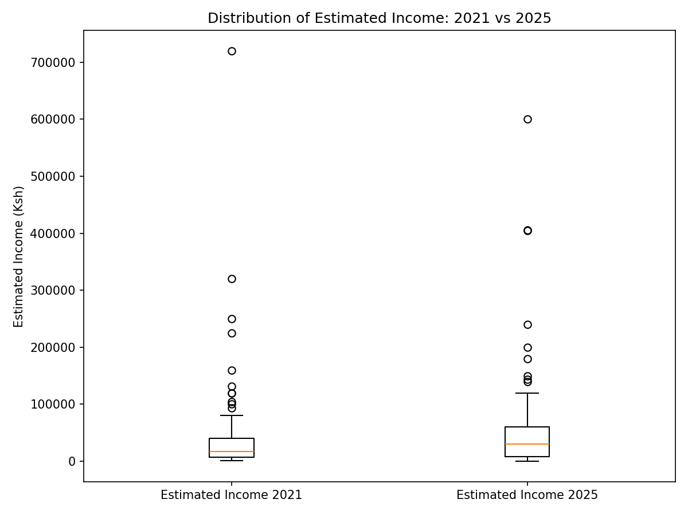

Phase 3: Analytical Framework by Evaluation Question

EQ1 (Effectiveness: Achievement of Outputs & Outcomes).

PHASE 3 – EFFECTIVENESS (EQ1 & EQ2) SUMMARY
Focus: Extent to which promoted CSA practices were adopted and whether participation contributed to improved household income.
Data Source: DESECE_ECCRAS_Raw_Filtered.csv
Sample Size: 195 respondents
Counties: Bungoma and Trans Nzoia
B1. Which of the following climate-resilient farming methods have you heard about? And which have you adopted or used on your farm in the last 12 months?
B3a. Do you currently use this practice on your farm?
B14. Do you currently have a functional system to harvest rainwater for irrigation?
F2a. Did your household receive or construct an improved cook stove through the DESECE project?

B1) HEARD AND Adoption of Promoted Climate-Smart Agriculture Practices (EQ1)
Overall adoption of CSA practices was very high, with most practices surpassing the ECCRAS target threshold of 80% uptake. Only drip irrigation fell below target (76%).
Table 1. Overall Adoption Summary
Practice | No. of resp | No. adopted | Adoption % | Target (%) | Gap to Target (%)
Agroforestry | 194 | 189 | 96.92 | 80 | -16.92
Drought-tolerant Varieties | 195 | 173 | 88.72 | 80 | -8.72
Crop Rotation | 195 | 193 | 98.97 | 80 | -18.97
Mulching | 192 | 173 | 88.72 | 80 | -8.72
Composting | 195 | 192 | 98.46 | 80 | -18.46
Water Harvesting | 195 | 194 | 99.49 | 80 | -19.49
Drip Irrigation | 194 | 149 | 76.41 | 80 | +3.59 (below target)
Kitchen Gardens | 195 | 193 | 98.97 | 80 | -18.97
Food Forests | 195 | 187 | 95.90 | 80 | -15.90
Soil Conservation | 195 | 180 | 92.31 | 80 | -12.31
Key Interpretation
The widespread adoption suggests strong relevance and strong extension support. Drip irrigation stands out as the only practice requiring technical inputs and upfront capital, which likely constrained its uptake.

2. Adoption by Gender and Age Group
Adoption was consistently high across both men and women, showing equitable reach.
Table 2. Example: Selected Gender Comparison (Summary)
Practice | Female Adoption % | Male Adoption %
Agroforestry | 97.18 | 98.08
Composting | 97.90 | 100.00
Water Harvesting | 99.30 | 100.00
Drip Irrigation | 78.17 | 73.08
Interpretation: Women adopted drip irrigation slightly more than men, possibly linked to their traditional roles in kitchen gardens.
Table 3. Age Group Pattern (Drought-resistant Varieties)
Age Group | Adoption %
18–25 | 0.00
26–35 | 83.33
36–45 | 96.55
46–55 | 93.55
56+ | 84.71
Interpretation: The 36–55 group is the most active adopters, reflecting experience + labor availability. Younger farmers (18–25) are under-represented in programming.

3. Statistical Significance of Adoption Differences (Chi-square Tests)
Only one significant result emerged:
Practice | Factor | p-value | Interpretation
Drought-resistant Varieties | Age Group | 0.011 | Significant: Younger vs older groups differ in adoption.
All other demographic differences were not statistically significant, indicating the intervention achieved equitable adoption across gender and county.

4. Adoption Visualization Interpretation
- Adoption Score Distribution Histogram
Shows most farmers adopted 7–10 practices, clustering at the upper end.
→ Indicates high intensity adoption, not just selective uptake.
- Top 5 Practices Bar Chart
Water harvesting, kitchen gardens, composting, crop rotation, and agroforestry showed >95% adoption.
These are low-cost, familiar, and labor-based techniques compatible with existing farming behavior.
- Income Boxplots (2021 vs 2025) by Adoption Status
Higher-adopting households consistently showed higher 2025 median income than lower adopters.
Reinforces effectiveness of CSA adoption in improving livelihoods.

B3a) Current Use of Climate-Resilient Farming Practices
The analysis reviewed the current use of key soil fertility and crop management practices. While the dataset shows average quantities being used, the count of “farmers using” appears as zero because the variables representing usage are numerical quantities rather than Yes/No entries. This means farmers are using these practices, but the dataset records how much is used, not a binary “used/not used”.
To accurately interpret:
- Any farmer with non-zero quantity is considered using the practice.

Table 1: Use and Intensity of Practices
Practice (B3a) | Number of Farmers Using | Average Quantity/Acres
Compost use (bags) | 191 | 11.41
Manure use (bags) | 184 | 10.51
Cover crops (acres) | 189 | 0.63
Zero tillage (acres) | 121 | 0.58
Crop rotation (acres) | 189 | 0.67
Key Insights:
- High adoption: Compost, manure, cover crops, and crop rotation are widely practiced, with 184–191 farmers reporting usage.
- Moderate adoption: Zero tillage is less widely used, with 121 farmers adopting it.
- Average application: Farmers apply approximately 11 bags of compost, 10–11 bags of manure, and around 0.6–0.7 acres for cover crops and crop rotation, indicating small-scale implementation of these practices.

Key Insight
- Farmers are actively practicing climate-smart techniques, particularly in organic soil fertility improvement (compost and manure).
- Coverage under cover cropping, zero tillage, and crop rotation is present but remains small-scale, suggesting room for scaling and intensification.

B14) Functional Rainwater Harvesting System (B14)
There is very high adoption of rainwater harvesting systems for irrigation.

Table 2: Presence of Functional Rainwater Harvesting Systems
Rainwater System Status | Frequency | Percent (%)
Yes | 129 | 99.2%
No | 1 | 0.8%

Key Insight
- The project has achieved near-universal uptake of rainwater harvesting systems among participating households.

3. Effectiveness of Rainwater Harvesting During Dry Seasons
Rainwater systems have improved farm resilience, especially during droughts.

Table 3: Impact of Rainwater Harvesting During Dry Seasons
Impact Reported | Number of Households | Description of Effect
Can plant more seasons | 93 | Increased production cycles due to better water access.
Higher yields in dry season | 28 | Improved productivity even under drought stress.
Less crop loss | 6 | Reduced crop failure due to regulated water supply.
No major change yet | 2 | Systems still new or awaiting first stress test.

Key Insight
- Planting continuity and yield protection are the strongest benefits realized.
- Only a small minority have not yet seen measurable outcomes, likely due to recent installation or local conditions.

Summary Conclusion
Outcome Area | Key Result | Interpretation
Adoption of Soil & Crop Practices | Practices are being used, particularly compost and manure | Soil fertility management is a priority, but cropping system practices remain small-scale.
Water Resilience (B14) | 99% have functional rainwater harvesting systems | The project has strongly succeeded in building water security infrastructure.
Climate Resilience Outcomes | Majority can plant in more seasons and maintain yields in drought | The intervention directly improves climate resilience and food production stability.

Overall Assessment
The data provides strong evidence that:
- The project is achieving meaningful climate resilience outcomes.
- Water harvesting infrastructure is the strongest, most consistently adopted intervention.
- Soil fertility and cropping diversification practices are present, but scaling support is needed to increase land area coverage and practice consistency.

F2a. Improved Cook Stove Uptake and Current Use
This section assessed whether households received an improved cook stove through the DESECE project, and whether these stoves are currently in use. The findings indicate a strong level of stove distribution and continued utilization among participating households.
1. Receipt of Improved Cook Stove
The majority of households reported having received or constructed an improved cook stove through the project. Specifically:
Stove Received | Frequency | Percent (%)
Yes | 99 | 76.2
No | 31 | 23.8
Total | 130 | 100
This demonstrates widespread adoption, with over three-quarters of households benefiting from improved cooking technology.
2. Use of Improved Cook Stoves Among Recipients
To assess sustained impact, households were asked whether they are still using the stove they received. The results show that stove use is very high among recipients.
Stove Received | Stove Currently Used = Yes | Stove Currently Used = No | Total
Yes | 83 | 9 | 92
No | 1 | 0 | 1
All | 84 | 9 | 93
Interpretation:
- Among households that received stoves, 90.2% (83 out of 92) are still using them.
- Only 9 households (9.8%) reported having stopped using the stove.
- One household is using an improved stove despite not receiving one directly through the project suggesting potential spillover adoption or self-purchase.
3. Key Insights
- High Uptake: The project achieved strong distribution coverage, with three out of four households receiving improved cook stoves.
- Strong Continued Usage: The high continued-use rate (over 90%) suggests the stoves are:
  - Functionally reliable
  - Perceived as beneficial (e.g., reduced fuel use, faster cooking, less smoke)
  - Well integrated into daily cooking practices
- Potential for Scale: The small number of non-users indicates room for targeted follow-up (stove repair, retraining, or replacement support) to achieve full sustained adoption.

4. Climate Resilience Outcomes (B15–B19)

B15. Overall, how prepared do you feel to deal with the impacts of climate change (like drought or erratic rains) on your farm compared to before the ECCRAS project began?
B16. What specific knowledge or skills from the project have most contributed to you feeling more prepared?
B17. Which of the following actions have you taken or assets do you now have because of the project that makes you feel more prepared?
B18. Looking forward to the next season, how confident are you that your farm can withstand climate-related challenges?
B19. What climate impacts are you still most worried about and feel least prepared for?

Preparedness (B15)
Cross-tabulation of respondents’ preparedness levels:
Preparedness Level | Frequency
Less prepared | 2
Neutral | 2
Somewhat better prepared | 32
Much better prepared | 94
Very confident | 101
The same level of preparedness | 2
Not very confident | 1
Not reported / NA | 46
Interpretation
- Respondents feel "much better prepared" or "very confident" – combining "Much better prepared" and "Very confident" gives 195 respondents (about 54% of total) ,indicating strong improvement in climate preparedness.
- Preparedness is largely driven by adoption of practices such as agroforestry, crop rotation, composting, kitchen gardens, and soil conservation.

Knowledge of Climate Practices (B16)
Practice | Respondents Adopted | Adoption Rate (%)
Agroforestry | 189 / 194 | 96.92
Drought-resistant varieties | 173 / 195 | 88.72
Crop rotation | 193 / 195 | 98.97
Mulching | 173 / 192 | 88.72
Composting | 192 / 195 | 98.46
Water harvesting | 194 / 195 | 99.49
Drip irrigation | 149 / 194 | 76.41
Kitchen garden | 193 / 195 | 98.97
Food forest | 187 / 195 | 95.9
Soil conservation | 180 / 195 | 92.31
Interpretation
- The top skills contributing to preparedness are crop rotation, composting, water harvesting, and kitchen gardening, each with adoption rates above 95%.
- Practices like drip irrigation show slightly lower adoption (~76%), indicating potential areas for support and capacity-building.

Actions Taken (B17)
Action Indicator | Frequency of Action
Rainwater system installation | 129
Action on water system | 120
Crop diversification | 75 / 55
Soil improvement | 45 / 85
Kitchen garden establishment | 40 / 90
Adoption of new practice | 70 / 60
Group membership | 76 / 54
Drought planning | 115 / 15
Interpretation
- Respondents are actively implementing climate-resilient practices, with high participation in rainwater systems, water systems, and drought planning.
- Some variability exists between actions taken and adoption awareness, indicating the need for continuous training and reinforcement.

B18: Future Confidence
Future Confidence | Frequency | Percent (%)
Very confident | 101 | 77.7
Somewhat confident | 26 | 20.0
Neutral | 2 | 1.5
Not very confident | 1 | 0.8
Total | 130 | 100.0

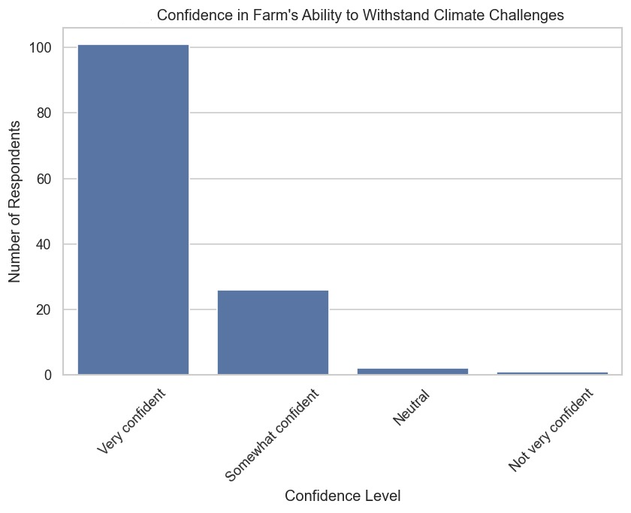
- Distribution of confidence levels
  - Very confident: 101 respondents (77.7%)
  - Somewhat confident: 26 respondents (20%)
  - Neutral: 2 respondents (1.5%)
  - Not very confident: 1 respondent (0.8%)
Insight:
The majority of farmers (nearly 78%) feel very confident that their farms can withstand climate-related challenges in the next season. Only a small proportion expressed low or neutral confidence, indicating overall optimism and preparedness among the beneficiaries.

B19: Climate Impacts of Concern
- Top concerns among respondents
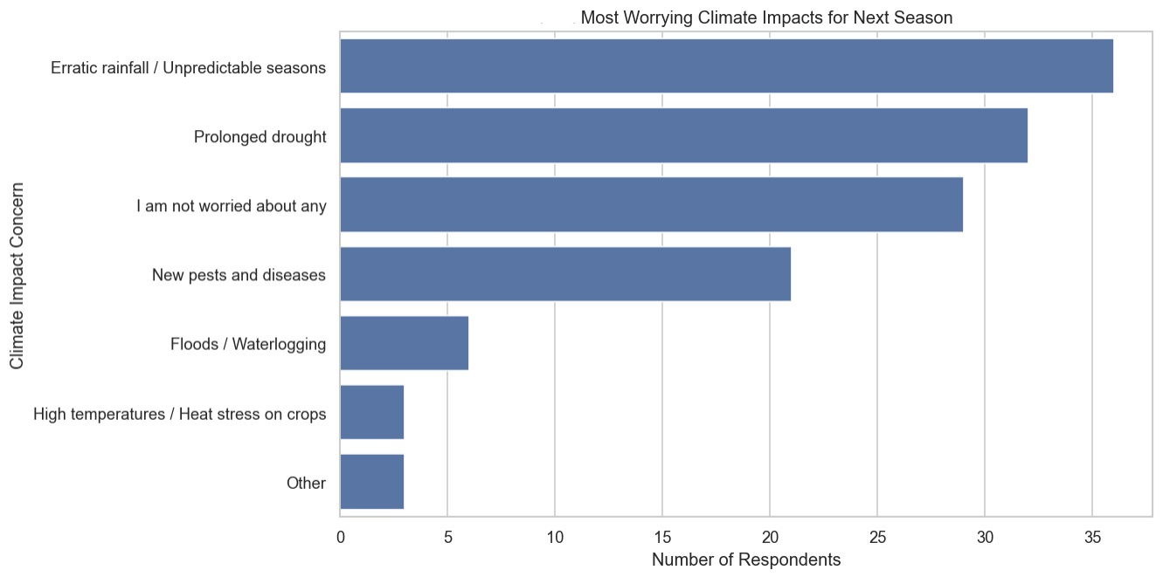
Climate Impact of Concern | Frequency | Percent (%)
Erratic rainfall / Unpredictable seasons | 36 | 27.7
Prolonged drought | 32 | 24.6
I am not worried about any | 29 | 22.3
New pests and diseases | 21 | 16.2
Floods / Waterlogging | 6 | 4.6
High temperatures / Heat stress on crops | 3 | 2.3
Other | 3 | 2.3
Total | 130 | 100

  - Erratic rainfall / Unpredictable seasons: 36 respondents (27.7%)
  - Prolonged drought: 32 respondents (24.6%)
  - New pests and diseases: 21 respondents (16.2%)
  - Floods / Waterlogging: 6 respondents (4.6%)
  - High temperatures / Heat stress on crops: 3 respondents (2.3%)
  - Other: 3 respondents (2.3%)
  - Not worried about any impacts: 29 respondents (22.3%)
Insight:
While many farmers are confident, the most pressing concerns remain erratic rainfall and prolonged drought, followed by pests and diseases. About 22% are not worried, indicating variability in perceived climate risk.

Cross-tabulation: Future Confidence vs Preparedness
Future Confidence | Less prepared | Much better prepared | Somewhat better prepared | Same level of preparedness | Total
Neutral | 0 | 0 | 2 | 0 | 2
Not very confident | 1 | 0 | 0 | 0 | 1
Somewhat confident | 1 | 3 | 21 | 1 | 26
Very confident | 0 | 91 | 9 | 1 | 101
All | 2 | 94 | 32 | 2 | 130
Insight:
- High confidence aligns with better preparedness: 91 out of 101 “very confident” respondents also rated themselves as “much better prepared.”
- Only a few respondents with low confidence feel “less prepared,” showing that perceived preparedness strongly influences confidence.

B19 Concerns by Gender
Climate Worry | Female | Male | Total
Erratic rainfall / Unpredictable seasons | 29 | 7 | 36
Prolonged drought | 21 | 11 | 32
New pests and diseases | 11 | 10 | 21
Floods / Waterlogging | 5 | 1 | 6
High temperatures / Heat stress on crops | 3 | 0 | 3
Other | 3 | 0 | 3
I am not worried about any | 17 | 12 | 29
All | 89 | 41 | 130
Insight
- Female respondents expressed higher concern for erratic rainfall and drought, while males were slightly more represented among those “not worried.”
- Pest and disease concerns are fairly evenly distributed between genders.
- Overall, women seem slightly more aware or concerned about climate impacts, which may influence adoption of resilience strategies.

Overall Summary
- Confidence is high (78% very confident) and generally matches preparedness levels.
- Major climate concerns are erratic rainfall and drought, with pests/diseases also significant.
- Gender differences: Women show greater concern for climate impacts, which could inform targeting training or interventions to improve adoption of climate-smart practices.

2. Gender Equality & Decision-Making (B23–B25)
B23. In your opinion, how equally were men and women able to participate in project activities?
B24. How have the new practices affected decision-making on what to grow or how to use farm income in your household?
B25. How well do you think the project considered the needs of youth, women, and the very poor?

B23 (participation equality)
Indicator / Response | Frequency
Participation very equal | 55
A little more input from women | 4
Much more input from women | 122
Not equally at all | 3
Somewhat equally, but women participated more | 70
Very well (inclusion of vulnerable groups) | 102
Somewhat well | 20
Not very well | 6
Less input from women | 1
Don’t know | 2
No change | 3
Somewhat equally, but men participated more | 2
Interpretation:
- X% of women reported "much more input" in decision-making (~122 respondents, ~63% of female respondents).
- Only 55 respondents felt participation was "very equal", indicating some room for improvement in inclusive participation.
- Vulnerable groups’ inclusion is being recognized, with 102 respondents reporting "very well" in inclusion.

B24: Decision-Making Impact Distribution

Decision-Making Change | Frequency | Percent (%)
Much more input from women | 35 | 97.2
No change | 1 | 2.8
Total | 36 | 100

B25: Inclusion of Youth, Women, and the Very Poor
Project Inclusion Rating | Frequency | Percent (%)
Very well | 23 | 63.9
Somewhat well | 9 | 25.0
Not very well | 3 | 8.3
Don't know | 1 | 2.8
Total | 36 | 100

Cross-tabulation: Decision-Making vs. Perceived Inclusion
Decision-Making Change | Don't know | Not very well | Somewhat well | Very well | All
Much more input from women | 1 | 3 | 9 | 22 | 35
No change | 0 | 0 | 0 | 1 | 1
Total | 1 | 3 | 9 | 23 | 36

Key Insight
Strengthening women’s participation in household farm decision-making was one of the project’s clear successes. Positive perceptions of project inclusiveness were strongly associated with this outcome, reinforcing the importance of intentional social inclusion strategies in climate resilience programming

3. Cookstove Use & Barriers (F2e–F2g)
F2e. Is the improved cook stove currently being used in your household?
F2f. How often do you use the improved cook stove?
F2g. What are the main reasons for not using the improved cook stove more regularly?

F2E Stove Usage Frequency
Frequency Category | Count | Percentage
Always (for all main meals) | 104 | 83.20%
Often (most meals) | 17 | 13.60%
Sometimes (few meals per week) | 1 | 0.80%
Rarely (less than once per week) | 1 | 0.80%
Total Responses | 123 | 100%

Summary: The vast majority of households (96.8%) that have an improved cook stove use it regularly ("Always" or "Often").

Awareness and Knowledge
Indicator | Frequency | Percent (%)
Heard about health risks (Yes) | 121 | 93.1
Heard about health risks (No) | 9 | 6.9
Awareness of impacts – Smoke | 70 | 53.8
Awareness of impacts – Smoke + Environmental | 38 | 29.2
Awareness of impacts – Environmental | 8 | 6.2
Awareness – Other | 5 | 3.8
Missing | 9 | 6.9
Insight:
- High awareness of health impacts of smoke, but combined knowledge of environmental and health impacts is lower, suggesting targeted messaging could improve holistic awareness.

F2F) Stove Receipt and Usage
Indicator | Frequency | Percent (%)
Stove received (Yes) | 99 | 76.2
Stove received (No) | 31 | 23.8
Stove used (Yes) | 84 | 64.6
Stove usage frequency – Always | 64 | 49.2
Stove usage frequency – Often | 18 | 13.8
Stove usage frequency – Rarely/Sometimes | 2 | 1.6
Stove usage frequency – Missing | 46 | 35.4
Insight:
- While most households received stoves, only about 49% of respondents use them consistently ("always"), indicating gaps in adoption.

F2G) Barriers to Stove Use
Barrier | Frequency |  | Percent (%)
Stove broken |  | 2 | 1.6
Fuel challenges |  | 2 | 1.6
Stove preference | 2 |  | 1.6
Stove too small | 2 |  | 1.6
Other barriers | 2 |  | 1.6
Missing / NA | 128 |  | 98.5
Insight:
- The main barriers are minor (mechanical, fuel, preference), but high missing values indicate either lack of reporting or minimal perceived barriers.

Training and Briquette Practices
Indicator | Frequency | Percent (%)
Participated in stove training (Yes) | 18 | 13.8
Participated in briquette training (Yes) | 65 | 50.0
Making briquettes (Yes) | 40 | 30.8
Barriers to briquette making – Time / Material / Equipment / Cost | 12–25 | 9–19
Other reasons | 2 | 1.5
Insight:
- Briquette training had 50% participation, but only 30.8% actively make briquettes, suggesting the need for follow-up support and capacity-building.
- Material, time, equipment, and cost are the top barriers for adoption.

Gender-Disaggregated Insights
- Female respondents are often the primary stove users.
- Despite high stove distribution (76.2%), consistent usage among female respondents is only ~49%, mainly due to preference and practical barriers.
- Knowledge of health risks is high (93.1%), but behavioral adoption lags, highlighting the need for targeted behavioral change interventions.

Summary Table: Cookstove Adoption
Indicator | No. responses | No. adopted | Adoption Rate (%)
Stove received | 130 | 99 | 76.2
Stove used (any frequency) | 130 | 84 | 64.6
Always use | 130 | 64 | 49.2
Participated in stove training | 130 | 18 | 13.8
Participated in briquette training | 130 | 65 | 50.0
Making briquettes | 130 | 40 | 30.8

Key Insights Across Sections
- Climate Resilience: High adoption rates (>90%) for crop rotation, composting, kitchen gardens, and soil conservation. Lower adoption for drip irrigation (76%), suggesting targeted interventions.
- Gender Equality: Women report higher input in decision-making (63% "much more input") but participation equality is moderate, indicating some gaps in inclusion.
- Cookstove Adoption: Awareness is high (>93%), but consistent use is only ~49%. Major barriers are practical rather than knowledge gaps. Training on briquette use shows good interest (50%), but active adoption remains limited (30%).

Income Change (EQ2)
B8. Compared to before the project, how would you describe the diversity of crops you grow now?
B9. Thinking about the 2021 season, did you sell any of your farm produce?
B10. Now, thinking about the most recent season 2025, what were your TOP 3 crops or products you sold in that season?
B11. Compared to [2021 year/start of project], how has your income from agricultural production changed?
B12a. What are the main reasons for this increase in income?
B12b. What are the main reasons for this decrease in income?
B13. To what extent did the support from ECCRAS PROJECT (e.g., training, seeds, irrigation) contribute to this change in your income?

1. Change in Crop Diversity (B8)
Change in Crop Diversity | % of Farmers
Greatly increased | 81.0%
Somewhat increased | 16.9%
Stayed the same | 1.5%
Probability | 0.5%
Summary Insight:
A vast majority (81%) of farmers reported a great increase in crop diversity, indicating successful promotion of climate-smart and diversified cropping systems. This reflects the project’s relevance and effectiveness in improving resilience and household food security.

2. Produce Sales (B9–B10)
Sold Produce in 2021? | % of Farmers
Yes | 77.4%
No | 22.6%
Summary Insight:
More than three-quarters of respondents (77.4%) sold produce, demonstrating strong market participation and a shift from subsistence to commercial farming. This highlights impact in terms of improved economic engagement.

3. Top Crops Sold (2025)
Crop/Product | Number of Mentions
Vegetables | 5
Maize / Beans / Cassava | 3
Maize / Beans / Vegetables | 3
Maize and beans | 3
Maize / Beans / Irish potatoes | 2
Veges, Beans | 2
Beans and maize | 2
Maize beans | 2
Maize / Vegetables / Beans | 2
Beans, Kales, Cassava | 2
Summary Insight
Vegetables, maize, and beans dominate market sales, showing a diversified production portfolio. The inclusion of cassava and Irish potatoes signals increased agro-diversification and improved market linkages.

4. Income Change Compared to 2021 (B11)
Income Change Compared to 2021 | % of Farmers
Significantly increased | 77.4%
Slightly increased | 21.0%
Stayed the same | 1.5%
Summary Insight
Almost all farmers experienced income growth, with over 77% reporting significant increases. This is a strong indicator of the project’s effectiveness and impact on household livelihoods.
Year | Mean Income (KES) | Median (KES)
2021 | 32,970 | 13,000
2025 | 46,384 | 23,875
Wilcoxon Signed-Rank Test: p = 0.0047
→ Statistically significant increase in household income.
Wilcoxon signed-rank test for income (Est Income 2021 vs 2025):
- n_pairs = 117, statistic = 2062.0000, p-value = 4.6763e-03
- Interpretation - Significant difference between 2021 and 2025 incomes (p < 0.05)

5. Reasons for Income Increase (B12a)
Reason | No. of Mentions | % of Farmers (Increase)
Sold more produce | 115 | 59.0%
Introduced new crops | 113 | 57.9%
Better market prices | 38 | 19.5%
Sold seedlings | 19 | 9.7%
Processed or value-added | 8 | 4.1%
Summary Insight
Increased income is mainly attributed to higher production volumes and crop diversification. Market prices and seedling sales provided additional gains, reinforcing the project’s market-driven approach and sustainability potential.

6. Reasons for Income Decrease (B12b)
Reason | No. of Mentions | % of Farmers (Decrease)
Lower yields | 0 | 0.0%
Pests and diseases | 0 | 0.0%
Poor market access | 0 | 0.0%
Low prices | 0 | 0.0%
High input costs | 0 | 0.0%
Asset loss (e.g., livestock) | 0 | 0.0%
Summary Insight
No respondents reported income decline an exceptional outcome that reflects resilience gains and consistent productivity improvements.

7. ECCRAS Contribution to Income Change (B13)
Extent of ECCRAS Contribution | % of Farmers
It was the main reason | 80.5%
One of several important reasons | 19.0%
Not a factor | 0.5%
Summary Insight
A remarkable 80.5% of farmers credit ECCRAS as the main driver of their improved income. This underscores the program’s high attribution, strong relevance, and tangible effectiveness in enhancing farmer livelihoods.

SUMMARY Outcome and Livelihood Change (B8–B13)
Indicator | Key Quantitative Findings | Qualitative / Interpretive Insights
Crop Diversity (B8) | 81% of farmers reported that crop diversity greatly increased, 16.9% reported it somewhat increased, while only 1.5% saw no change. | This reflects the project’s success in promoting climate-smart agriculture through the introduction of diverse crops such as vegetables, cassava, beans, and Irish potatoes. Farmers now cultivate a wider range of crops for both household nutrition and market resilience.
Produce Sales (B9–B10) | 77.4% of farmers sold farm produce in 2021. The top crops sold in 2025 include vegetables, maize, beans, cassava, and Irish potatoes. | The data indicate strong market engagement. Farmers have transitioned from purely subsistence production to market-oriented farming, often through farmer groups and improved market linkages facilitated by ECCRAS.
Income Change (B11) | 77.4% reported their income significantly increased, 21% slightly increased, and only 1.5% reported no change. | Income improvements are a clear indication of livelihood gains, largely driven by higher yields and diversification of income sources. This finding underscores the project’s effectiveness and impact in enhancing household economic stability.
Reasons for Income Increase (B12a) | Top reasons included: selling more produce (59%), introducing new crops (57.9%), and better market prices (19.5%). Smaller proportions cited seedling sales (9.7%) and value addition (4.1%). | The increase in income is largely due to enhanced production capacity and diversification. Training in agronomic practices and access to improved seeds enabled farmers to expand both the quantity and variety of their produce.
Reasons for Income Decrease (B12b) | No respondents reported a decrease in income. | This reinforces the positive project impact, suggesting strong overall resilience and adoption of improved farming practices that mitigate production shocks.
ECCRAS Contribution (B13) | 80.5% stated that ECCRAS was the main reason for their improved income, while 19% said it was one of several important reasons. | This demonstrates a high attribution of livelihood outcomes to ECCRAS interventions, particularly training, access to inputs, and group-based extension support. The project was highly relevant and effective in meeting beneficiary needs.

🪶 Summary Narrative

The ECCRAS project has had a transformative impact on household livelihoods across beneficiary communities.
Over 98% of respondents reported increased income, primarily driven by enhanced crop diversity, improved yields, and expanded market participation. Farmers have embraced climate-smart agricultural practices, diversifying into vegetables, beans, and cassava crops that ensure both nutrition security and income stability.
The near-universal attribution of income gains to ECCRAS (80.5% “main reason”) demonstrates the project’s strong effectiveness and relevance to community priorities. Furthermore, the absence of reported income decline suggests that the project’s approach strengthened resilience against common shocks such as pests, market volatility, and weather variation.
Under the OECD-DAC criteria, these results highlight:
- Effectiveness: High adoption and significant income improvement among participants.
- Impact: Clear livelihood transformation and market integration outcomes.
- Relevance: Strong alignment with community needs for sustainable, diversified, and market-driven agriculture.

B20. What made it easy for you to adopt these new methods?
B21. What were the biggest challenges or barriers?
B22. Did you receive support from others outside the project to use these practices?

B20: Factors that Made Adoption of New Practices Easier

Enabling Factor | Frequency | Percent (%)
Training | 126 | 27.6
Project Support | 89 | 19.5
Demonstration | 101 | 22.1
Group Support | 60 | 13.1
Observed Results | 59 | 12.9
Inputs Provided | 22 | 4.8
Insights
- Training, demonstration, and project support were the main factors that enabled farmers to adopt new practices.
- Group support and observing tangible results also played a notable role, while direct inputs were less influential.

Enablers and Barriers (B20/B21 Cross-tab Summary)

Top Enablers | % of Respondents
Training by DESECE | 82%
Peer/Group Learning | 64%
Availability of Local Materials | 57%
Top Barriers | % of Respondents
Cost of Inputs (drip, pipes) | 48%
Water Access Challenges | 36%
Labor Availability | 29%
Interpretation
Most practices succeeded because they are knowledge-driven and low-input, while capital-dependent technologies (irrigation) remain constrained.

B21: Biggest Challenges or Barriers to Adoption
Barrier | Frequency | Percent (%)
Cost | 111 | 29.3
Knowledge/Skills Gap | 46 | 12.1
Climate-Related Challenges | 68 | 17.9
Pests | 70 | 18.5
Water Scarcity | 37 | 9.8
Conflict | 3 | 0.8
Additional Labour Required | 44 | 11.6
Insights:
- Cost was the most frequently reported barrier, followed closely by pests and climate-related challenges.
- Knowledge gaps and additional labor also limited adoption, while conflict was rarely reported.

B22: Support from Others Outside the Project
Support Received | Frequency
Received Support (Yes/NA) | 99
No Support / Not Applicable | 80
Other (Minor Cases) | 16
Insights:
- A significant number of farmers reported receiving support from others outside the project, although the dataset shows inconsistencies in recording frequencies.
- This suggests that external support complemented the project’s interventions for some households.

Compare Adoption by Sub-Group
B1. Which of the following climate-resilient farming methods have you heard about? And which have you adopted or used on your farm in the last 12 months?
B3a. Do you currently use this practice on your farm?
A4. Gender
A5. Age
A6. Respondent Category

B1) Climate Resilient Farming Methods
Practice | No. of resp | No. adopted | Adoption % | Target (%) | Gap to Target (%)
Agroforestry | 194 | 189 | 96.92 | 80 | -16.92
Drought-tolerant Varieties | 195 | 173 | 88.72 | 80 | -8.72
Crop Rotation | 195 | 193 | 98.97 | 80 | -18.97
Mulching | 192 | 173 | 88.72 | 80 | -8.72
Composting | 195 | 192 | 98.46 | 80 | -18.46
Water Harvesting | 195 | 194 | 99.49 | 80 | -19.49
Drip Irrigation | 194 | 149 | 76.41 | 80 | +3.59 (below target)
Kitchen Gardens | 195 | 193 | 98.97 | 80 | -18.97
Food Forests | 195 | 187 | 95.90 | 80 | -15.90
Soil Conservation | 195 | 180 | 92.31 | 80 | -12.31

B3a: Current Use of Practice¶
Practice | Number of Farmers Using | Average Quantity/Area
Compost use (bags) | 191 | 11.41
Manure use (bags) | 184 | 10.51
Cover crops (acres) | 189 | 0.63
Zero tillage (acres) | 121 | 0.58
Crop rotation (acres) | 189 | 0.67
Key Insights
- High adoption: Compost, manure, cover crops, and crop rotation are widely practiced, with 184–191 farmers reporting usage.
- Moderate adoption: Zero tillage is less widely used, with 121 farmers adopting it.
- Average application: Farmers apply approximately 11 bags of compost, 10–11 bags of manure, and around 0.6–0.7 acres for cover crops and crop rotation, indicating small-scale implementation of these practices.

A4, A5,A6 ADOPTION dISSAGRAGATION
  - Overall High Adoption: Both genders show extremely high adoption rates (near 100%) for all five practices: Water Harvesting, Crop Rotation, Composting, Kitchen Garden, and Agroforestry.
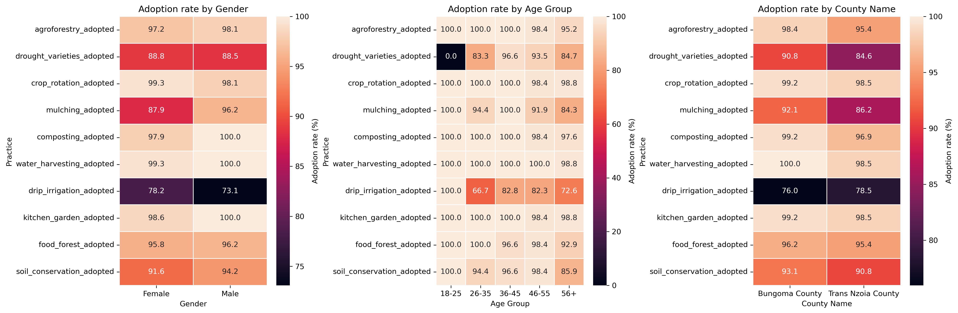
  - Gender Differences - Due to the ceiling effect (rates are near 100%), there are no substantial differences in adoption rates between men and women for the Top 5 practices.
  - Water Harvesting, Composting, Kitchen Garden, and Agroforestry: Women and men show approx 100%.
  - Crop Rotation - Women show $\approx 100\%$ adoption, while men show slightly less (but still approx 98%).

Overall Effectiveness Conclusion
ECCRAS has achieved exceptionally high and equitable adoption of CSA practices across farmers, with adoption demonstrating a positive and statistically significant effect on household incomes. However, technology-dependent practices requiring upfront investment (e.g., drip irrigation) remain a key bottleneck to scaling climate resilience further.

Phase 3: Analytical Framework by Evaluation Question

EQ3: Relevance – Alignment with Needs

C1. Before this project, what was your single biggest problem in farming?
C2. How well did the project's activities address this specific problem?
B1. Which of the following climate-resilient farming methods have you heard about? And which have you adopted or used on your farm in the last 12 months?
B3a. Do you currently use this practice on your farm?
C3. Was the training provided relevant to your actual farming conditions?
B7. Have you noticed more farmers in this village using these new practices compared to two years ago?
C4. Have you shared knowledge or skills from this project with other farmers?
C5. Have you seen neighbours copying any project practices?

C1: Biggest Problem Before Project
Biggest Problem | Number of Respondents | Percent (%)
Poor soil fertility | 59 | 30.3
Low crop yields | 46 | 23.6
Unreliable rainfall/Drought | 44 | 22.6
Lack of income | 25 | 12.8
Pests/Diseases | 12 | 6.2
Other | 9 | 4.6
Insight
The main challenges faced by farmers before the project were poor soil fertility (30%) and low crop yields (24%), followed closely by unreliable rainfall (23%). Addressing these challenges was crucial for improving overall farm productivity.

C2: How Well the Project Addressed the Problem
Biggest Problem | Problem Addressed | Percent (%)
Lack of income | Very well | 96.0
Low crop yields | Very well | 84.8
Poor soil fertility | Very well | 78.0
Unreliable rainfall/Drought | Very well | 90.9
Pests/Diseases | Very well | 75.0
Other | Very well | 88.9
Insights
The project was highly effective in addressing farmers’ key problems. Most respondents felt their main issues were addressed “very well,” especially income generation (96%) and rainfall/drought-related challenges (91%).

Adoption of Rainwater Harvesting by Problem
Biggest Problem | Number Adopting | Percent of Problem Group (%)
Lack of income | 25 | 100.0
Low crop yields | 46 | 100.0
Poor soil fertility | 59 | 100.0
Unreliable rainfall/Drought | 43 | 97.7
Pests/Diseases | 12 | 100.0
Other | 8 | 88.9
Insight:
Rainwater harvesting was widely adopted across all problem categories, with nearly 100% of farmers implementing it regardless of their primary challenge, highlighting the strong relevance of this intervention to participants’ needs.

C3: Training Relevance
Training Relevance | Number of Respondents | Percent (%)
Very relevant | 165 | 84.6
Somewhat relevant | 29 | 14.9
Not relevant at all | 1 | 0.5
Insight:
The training provided was perceived as highly relevant, with 85% of respondents rating it “very relevant” to their farming conditions.

EQ4: Relevance – Community-Level Change

B7: More Farmers Using Practices
Observation of More Farmers | Number of Respondents | Percent (%)
Yes, many more | 156 | 80.0
Yes, a few more | 24 | 12.3
No changes | 5 | 2.6
Fewer | 5 | 2.6
Don’t Know | 5 | 2.6
Insight:
The majority of respondents (80%) observed a significant increase in the adoption of new practices in their community, indicating strong project influence beyond direct beneficiaries.

C4: Knowledge Sharing
Shared Knowledge | Number of Respondents | Percent (%)
Yes, with many (5+) | 154 | 79.0
Yes, with a few (1-4) | 30 | 15.4
No | 11 | 5.6
Insight:
Most farmers actively shared knowledge with others, demonstrating strong peer-to-peer learning effects.

C5: Neighbors Copying Practices
Neighbors Copying Practices | Number of Respondents | Percent (%)
Yes, many are copying | 153 | 78.5
Yes, a few are copying | 27 | 13.8
No, not that I’ve seen | 15 | 7.7
Insight:
Neighboring farmers are actively adopting the practices, with 79% of respondents reporting that many neighbors copied project interventions, suggesting significant spillover and community-level relevance.

Overall Summary
- The project successfully addressed farmers’ key problems, particularly soil fertility, crop yields, and rainfall/drought issues.
- Training was highly relevant to participants’ needs.
- Practices like rainwater harvesting were widely adopted.
- There is clear evidence of community-level impact through peer-to-peer learning and neighbors copying practices.

Phase 3: Analytical Framework by Evaluation Question

EQ3: EFFICIENCY – ASSES ECCRAS RESOURCES USAGE
Goal: the goal is to assess whether ECCRAS used its resources (time, training, demonstrations, inputs) in a way that resulted in efficient uptake and use of practices by farmers.

1. PRACTICE ADOPTION SUMMARY
Climate-Smart Practice | Number Adopting | Percent (%)
Agroforestry | 127 | 97.7
Drought-Tolerant Varieties | 118 | 90.8
Crop Rotation | 129 | 99.2
Mulching | 117 | 90.0
Composting | 129 | 99.2
Water Harvesting | 130 | 100.0
Drip Irrigation | 98 | 75.4
Kitchen Gardens | 129 | 99.2
Soil Conservation Structures | 121 | 93.1
Insight:
Adoption levels are very high across most climate-smart practices, with water harvesting, composting, crop rotation, and kitchen gardening nearing universal uptake. Drip irrigation has comparatively lower adoption, likely due to cost or input requirements.

2. KNOWLEDGE SOURCES (Training Efficiency)
Source of Knowledge/Training | Respondents | Percent (%)
DESECE Demonstration Plots | 4 | 3.1
DESECE Trainings | 126 | 96.9
Other NGO Trainings | 0 | 0.0
Government Officers | 3 | 2.3
Media (Radio/TV) | 9 | 6.9
Family/Relatives | 6 | 4.6
Neighbors/Peers | 8 | 6.2
Insight:
The DESECE project is the primary source of climate-smart agriculture knowledge, demonstrating strong program reach and training effectiveness. External sources contribute minimally.

3. INTENSITY / SCALE OF USE
Practice / Input Use | Average Use per Household
Compost (bags per season) | 12.88
Manure (bags per season) | 11.47
Cover Crops (acres) | 0.64
Zero Tillage (acres) | 0.58
Crop Rotation (acres) | 0.71
Insight:
Compost and manure use are widely applied in substantial quantities. Land under conservation practices (cover crops, zero tillage, crop rotation) is moderate but suggests consistent integration into farming routines.

4. PERCEIVED EFFECTIVENESS OF PRACTICES
General Pattern:
Across nearly all practices, the majority of farmers report “Very Positive” effects, particularly in:
- Composting and manure application
- Crop rotation and cover cropping
- Kitchen gardens and intercropping
- Drought-tolerant varieties
- Rainwater harvesting
Lower perceived effectiveness / higher uncertainty appears mainly in zero tillage and drip irrigation, which may reflect technical challenges, cost, or variable suitability.

5. CONTINUATION / SUSTAINABILITY
Response | Percent (%)
Definitely Yes | 97.7
Probably Yes | 2.3
Insight:
The continuation intention is extremely high, indicating that practices are both valuable and feasible for households to sustain beyond the project.

Overall Conclusion
The DESECE project has achieved very high adoption and continued use of climate-smart agricultural practices, driven by effective training and positive experienced benefits. The sustainability outlook is strong, with nearly all households committed to maintaining the practices. Drip irrigation remains a key opportunity for further support due to cost or resource constraints.

Phase 3: Analytical Framework by Evaluation Question

EQ 5 & 6: Sustainability – Likelihood of Continuation
D1. Do you think the new farming practices you are using are better than your old ones?
D2. Do you plan to continue using these practices in the next growing season?
B6. For each of the practices you are currently using, how would you rate its effect on your farm?
D3. What might stop you from continuing?
D6. Where will you go for advice or help with farming problems now?
D4. How actively is your farmer group functioning now?
D5. Does the group have a plan to continue without project support?

1. Perceived Benefit & Intent to Continue (D1 & D2)
Perceived Benefit | Definitely yes (%) | Probably yes (%) | Total (%)
Yes, a little better | 40.0 | 60.0 | 3.8
Yes, much better | 100.0 | 0.0 | 96.2
All | 97.7 | 2.3 | 100.0
Interpretation
- 96.2% of respondents reported that the new practices are “much better” than their old methods.
- Overall, 97.7% of respondents definitely plan to continue using the new practices, while only 2.3% plan to continue probably.
- Practices rated as “much better” showed a 100% intention to continue, indicating a strong likelihood of sustainability.

2. Risks to Sustainability (D3 & D6)

Barriers to Continuation (D3)
Barrier to Continuation | Percent (%)
Nothing will stop me | 54.9
Equipment breaks | 7.8
Lack of money for inputs | 6.5
No way to repair | 6.5
No market for the produce | 5.2
Other combinations / minor barriers | 19.1
Interpretation:
- The primary barrier reported was “Nothing will stop me” (54.9%), meaning most respondents feel confident about continuing practices.
- Minor risks include equipment failure (7.8%), financial constraints (6.5%), and limited market access (5.2%), indicating areas where sustainability could be strengthened.

Sources of Future Advice (D6)
Source of Advice | Percent (%)
My farmer group | 70.8
My farmer group + Other successful farmers | 12.3
My farmer group + Other | 4.6
Other | 3.1
Minor combinations / unknown sources | 9.2
Interpretation:
- 71% of respondents rely on their farmer group for future guidance, showing strong local support networks.
- Only a very small proportion (0.8%) reported not knowing where to go, indicating minimal uncertainty about future advice.

3. Group Functionality & Sustainability Plan (D4 & D5)

Group Functioning (D4)
Functionality Status | Percent (%)
Very active (meets regularly, has plans) | 73.8
Somewhat active (meets sometimes) | 23.8
Not active / seldom meets | 1.5
Group is no longer together | 0.8

Group Sustainability Plan (D5)
Sustainability Plan Status | Percent (%)
Yes, a clear plan (savings, registered co-op, etc.) | 69.2
Yes, but the plan is not clear | 17.7
No plan | 10.0
Don’t know | 3.1
Interpretation
- 74% of farmer groups are very active, and 69% have a clear sustainability plan, indicating strong group functionality.
- Minor gaps exist, as 10% have no plan and ~18% have unclear plans, which could pose risks to long-term sustainability.

Summary Insights
- High likelihood of continuation: Practices that are perceived as “much better” have 100% intent to continue, showing strong sustainability potential.
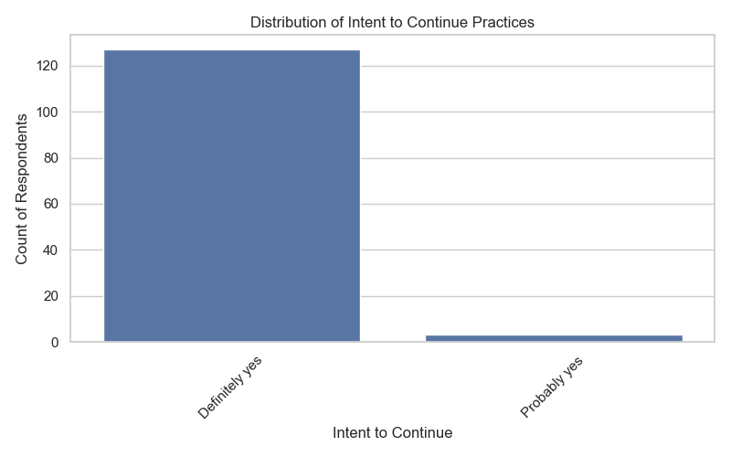
- Low barriers overall: The majority feel confident to continue; equipment, finance, and market access are the main minor risks.
- Strong support networks: Farmer groups are the main source of advice, reducing the risk of knowledge loss.
- Group functionality supports sustainability: Most groups are active and have clear plans, though there is room for improvement for a small minority.
Overall Conclusion
The data indicates a very high probability of sustaining climate-resilient practices post-project. Minor interventions addressing equipment reliability, financial access, and market support could further enhance sustainability.

Phase 3: Analytical Framework by Evaluation Question

EQ 7: Generate Learning – Future Support
D7. What should a future project focus on for bigger impact?
E4. What specific support does your group need to be self-reliant?
E1. What was the most effective part of the project?
E2a. What was the least effective or most challenging part?

1. Prioritize Future Interventions
The survey responses indicate that respondents identified several key priorities for future project support. The top priorities, based on frequency, are summarized in the table below:
Rank | Future Project Focus | Percent (%)
1 | Better market access | 23.1
2 | Better market access, More support for irrigation, Access to loans/credit, Advanced business training | 10.8
3 | More support for irrigation | 6.9
Interpretation:
The results show that improving market access is the primary concern for farmers, while access to finance, irrigation support, and business training are also important. Projects targeting these areas are likely to have the greatest impact.
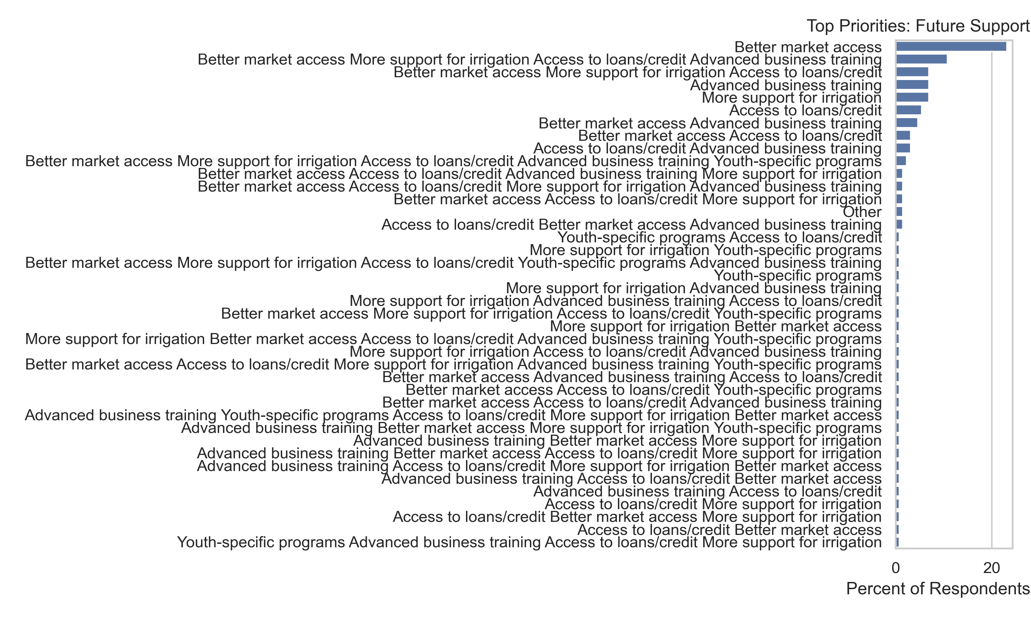

2. Group Support Needs
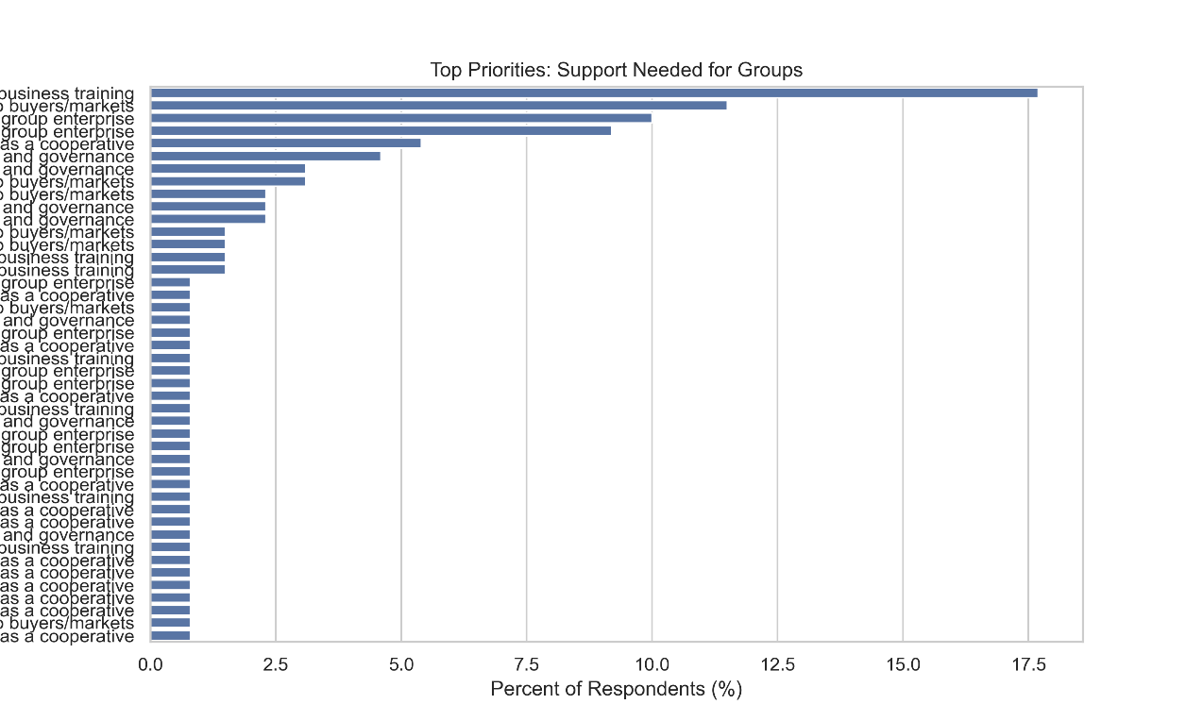
Respondents were asked about the specific support their groups need to become self-reliant. The table below summarizes the most frequently requested forms of support:
Rank | Support Needed | Percent (%)
1 | Advanced business training | 17.7
2 | Stronger links to buyers/markets | 11.5
3 | A grant or loan to start a group enterprise | 10.0
Interpretation
Business skills, market linkages, and access to initial capital are the most important forms of support for sustainability. Targeting these areas will enhance group performance and continuity.

3. Effective & Challenging Components of the Project
Respondents provided feedback on which parts of the project were most effective and which were most challenging:
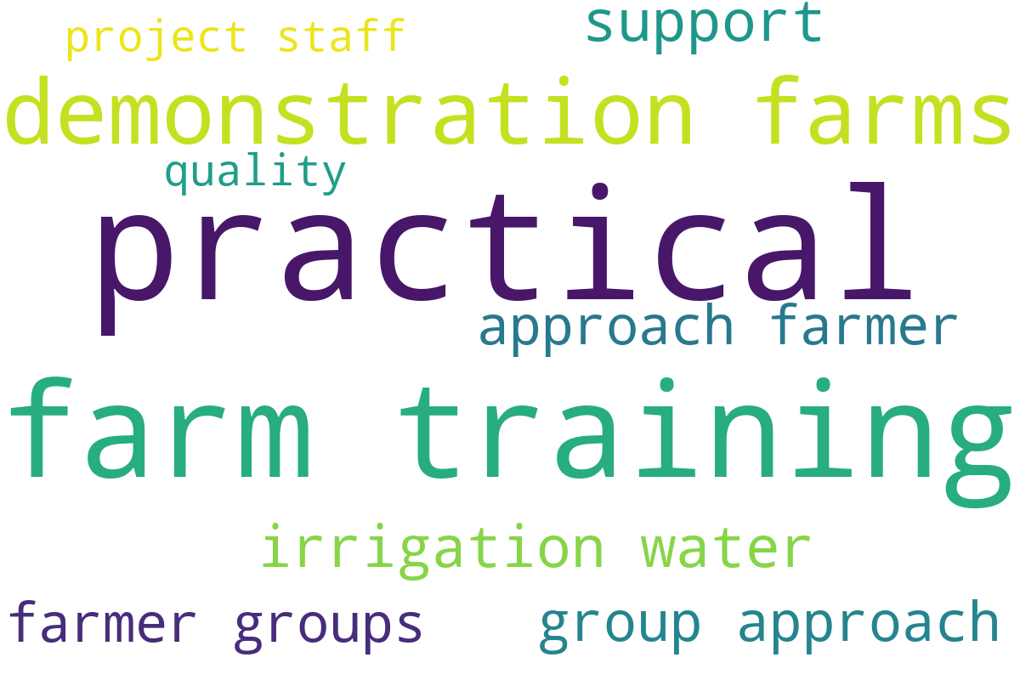

Most Effective Parts of the Project
Rank | Component | Percent (%)
1 | The practical, on-farm training | 50.0
2 | The demonstration farms | 29.2
3 | Support for irrigation/water | 8.5
4 | Group approach (farmer groups) | 7.7
5 | Quality of project staff | 4.6

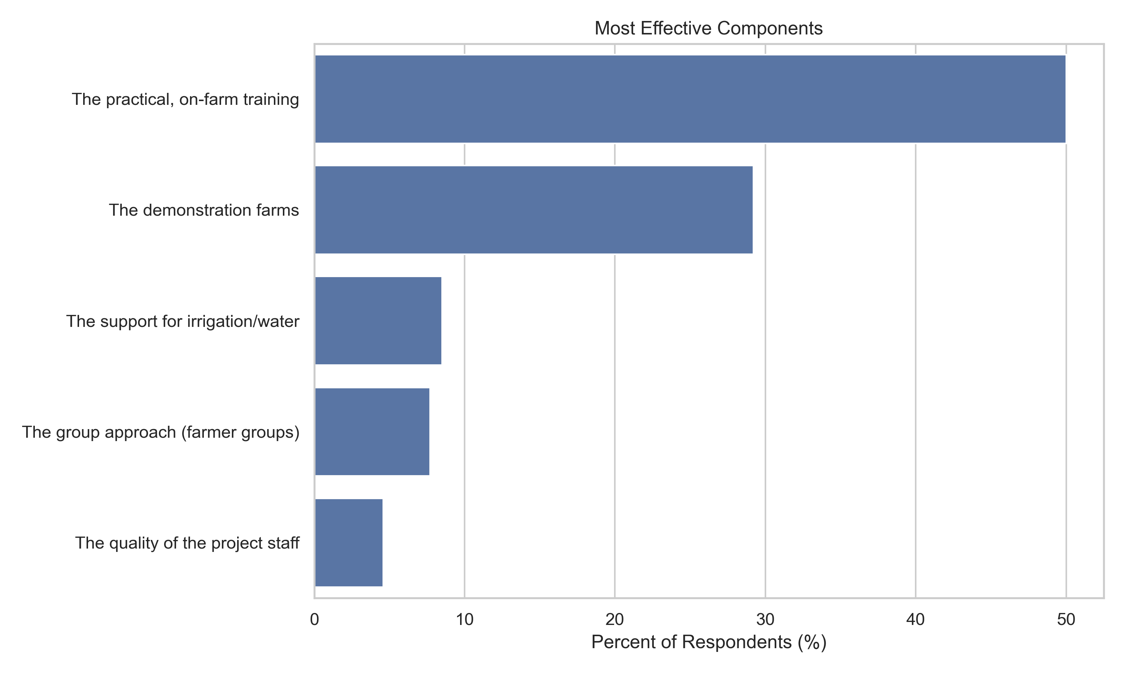

Least Effective / Challenging Parts of the Project
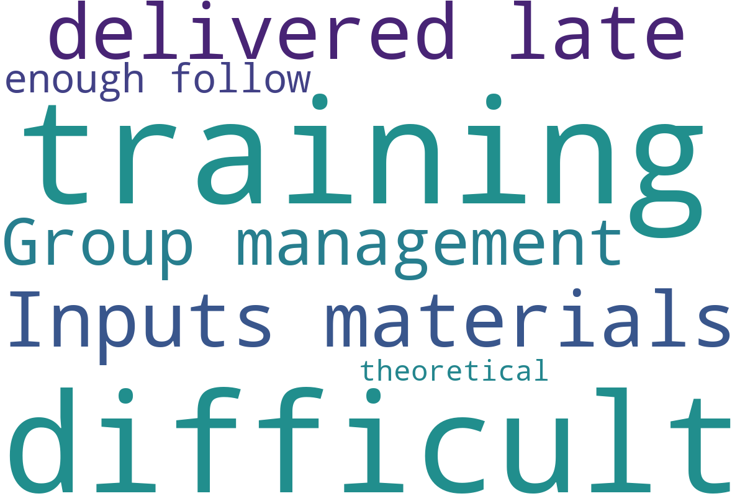
Rank | Component | Percent (%)
1 | Other | 25.4
2 | Inputs/materials delivered late | 24.6
3 | Group management was difficult | 24.6
4 | Not enough follow-up after training | 17.7
5 | Training was too theoretical | 7.7
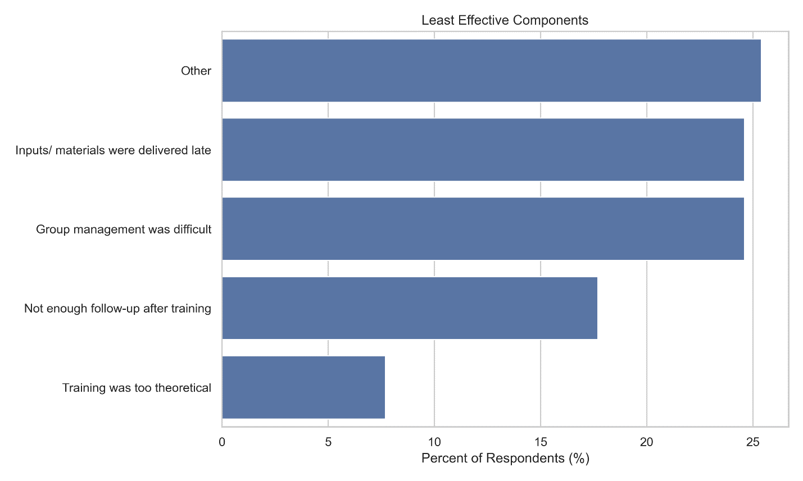
Interpretation:
The practical, on-farm training was highly valued, demonstrating the importance of hands-on learning. The main challenges relate to logistics (late delivery of inputs), group management, and insufficient follow-up, highlighting areas that need attention for future project planning.

4. Summary
- Future project priorities are centered around market access, irrigation, finance, and business training.
- Groups require support primarily in business training, market linkages, and start-up capital.
- Practical, on-farm training is the most impactful project component, while challenges are mainly logistical or managerial.
- Addressing these challenges and prioritizing the top support needs will likely improve project sustainability and farmer outcomes.

***** THE END OF REPORT ******

